
Koneru Lakshmaiah Education Foundation
(Deemed to be University estd. u/s. 3 of the UGC Act, 1956)
Off-Campus: Bachupally-Gandimaisamma Road, Bowrampet, Hyderabad, Telangana - 500 043. Phone No: 7815926816, www.klh.edu.in

STUDENT CASE STUDY EXECUTION REPORT
Department | FED
Sub'ect | DSA-2
Academic Year | 1-III Semester | 2025-26
Facult Name | Mohd.Razia
Student Name | U.Shiva Reddy
Roll Number | 2520090172
Branch | CSIT
Course Outcome | CO-6
Case Study Topic: Team Selection Optimization using 0/1 Knapsack Dynamic Programming
Work Done Summary:
In the SportsAnalytics system, team managers need to select the best combination of athletes within a limited budget while maximizing overall performance. This problem is modeled as a 0/1 Knapsack Problem, where each athlete has a cost and a performance score. Dynamic Programming is used to determine the optimal team selection.
Athlete | Cost | Performance Score
A1 | 2 | 40
A2 | 3 | 50
A3 | 4 | 65
A4 | 5 | 75

Implementation Details:
1) Consider each athlete as an item.
2) Cost represents the weight.
3) Performance score represents the value.
4) Apply Dynamic Programming (0/1 Knapsack).
5) Construct DP table.
6) Find maximum achievable performance score under budget constraints.
7) Analyze optimal athlete selection.
Result: Screenshots / Output

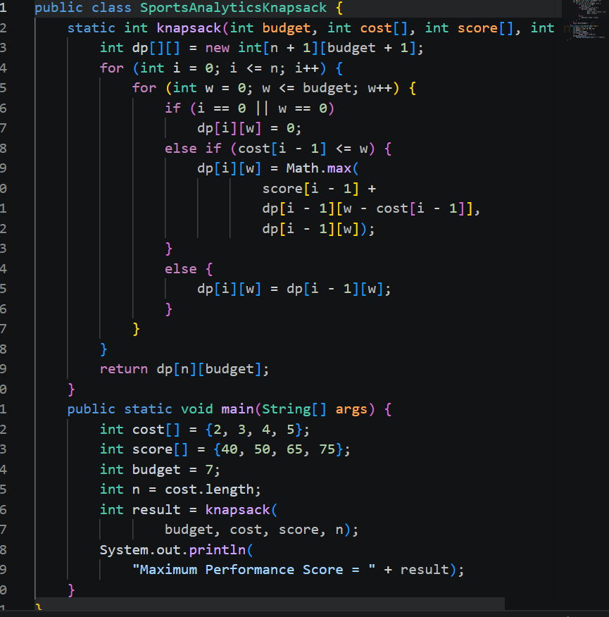

GitHub Link: https://github.com/Shiva77661/SportsAnalytics-Athlete-Performance-Tournament-Management-System/blob/main/Sports%20AnalyticsKnapsack
Student Signature Faculty Signature

